BRAVERMAN I GREENSPUN

A PROFESSIONAL CORPORATION

LIKE A GOOD NEIGHBOR, STAY OVER THERE
By: Kelly A. Ringston, Esq.

Every New Yorker is familiar with the ubiquitous sidewalk shed. For condominium and cooperative boards and owners, the metal and plywood eyesore designed to keep pedestrians safe from falling debris and construction material is a dreaded, but necessary, part of making repairs or improvements to their building. But what if it the sidewalk shed preparing to darken the door of your residence isn't because of construction at your building, but at your neighbors? Or worse, what if that neighbor advises that it must erect scaffolding on your outdoor terrace...in June?
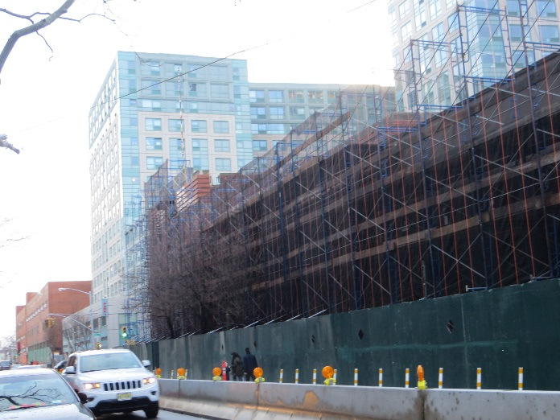
In New York City, where space is valued at a premium, buildings are often built right up to adjacent property lines. This maximizes the useable space of each lot of land, but can make it nearly impossible to undertake construction at one property without accessing a neighboring property. Moreover, Department of Building regulations require building owners to adequately protect neighboring buildings from damage or injury during construction or demolition work, and the associated building protections (such as sidewalk sheds, debris netting, roof protections and vibration monitoring) must often be installed on the properties that they are intended to protect. Add in the City's mandatory Façade Inspection Safety Program, which requires all buildings with six or more stories to have their exterior walls and appurtenances inspected periodically, and it becomes likely that all condominium and cooperative boards will be faced with a request for access from a neighboring building at least once.
The bad news for boards is that they can compelled by the court to provide access to their properties if a neighboring landowner cannot perform repairs or improvements to its own property without entering onto their adjacent property. Section 881 of the Real Property Actions and Proceedings Law provides that:
When an owner or lessee seeks to make improvements or repairs to real property so situated that such improvements or repairs cannot be made by the owner or lessee without entering the premises of an adjoining owner or his lessee, and permission so to enter has been refused, the owner or lessee seeking to make such improvements or repairs may commence a special proceeding for a license so to enter pursuant to article four of the civil practice law and rules. The petition and affidavits, if any, shall state the facts making such entry necessary and the date or dates on which entry is sought. Such license shall be granted by the court in an appropriate case upon such terms as justice requires. The licensee shall be liable to the adjoining owner or his lessee for actual damages occurring as a result of the entry.

In order to meet its burden of proof, a neighbor seeking a court ordered license for temporary access under RPAPL 881 must establish that entry upon an adjacent property is truly necessary (rather than more convenient) and must specify the dates, or timeframe, for which access is sought.

The good news for boards is that a temporary license, if granted, will not be unconditional. 881 provides, at a minimum, that the entering owner is liable for any actual damages which result from its entry onto a neighboring property. In addition, it is not uncommon for courts to conclude that “justice requires” a license to: (i) provide for certain safeguards to ensure against damage the adjacent property (such as insurance, bonds, and/or the establishment of an escrow fund); (ii) reimburse neighboring buildings for costs resulting from access (including engineering fees incurred in reviewing a neighbor’s drawings, plans and permits and attorneys’ fees incurred in negotiating access); and (iii) compensate owners for any loss of use of their property during the access period through a license fee.

Nonetheless, judges can, and do, have differing opinions on what protections should be put in place, what costs should be reimbursed and what level of compensation is appropriate. Accordingly, condominium and cooperative boards are well served by attempting to negotiate a voluntary license agreement with their neighbors rather than waiting for the commencement of a lawsuit by their neighbor, incurring the cost and aggravation of litigation and hoping for a favorable outcome.
The first step of such a negotiation is usually for boards to request, if it has not already been provided, a copy of the neighboring building’s plans, drawings, and/or permits for review by the condominium or cooperative’s own architect, engineer or construction professional, so that the full scope of access can be understood and any potential concerns can be identified. A well drafted license agreement will address any concerns that boards have related to access and secure more comprehensive protections for their buildings than may be awarded by the Court. By way of example, while a court ordered license should include a requirement that a neighbor must obtain and maintain an appropriate insurance policy naming the adjacent properties as additional insureds, a voluntary license agreement can dictate the required insurance policy limits, exclusions and endorsements, require that insurance be obtained from a highly rated carrier, require that the policy cannot be canceled without advance notice to the additional insureds, and provide the condominium or cooperative’s insurance broker an opportunity to review and approve the resulting certificates of insurance.
It is also commonplace for access agreements to provide for the reimbursement of professional fees incurred by condominium or cooperatives in connection with a neighbor’s request for access. Typically, this includes the cost to have an engineer or other professional review the relevant drawings, plans and permits, and the cost to have an attorney negotiate and draft an access agreement. If access will require the continuing involvement of these professionals, the agreement can provide for the reimbursement of future expenses as well. Lastly, to the extent that a neighbor’s need for access will result in the loss of the use and enjoyment of any portion of the condominium or cooperative property (such as the loss of the use of a terrace in June), a monthly license fee to compensate the board or impacted owner can be negotiated as well.
Although the goal of any negotiation should be to reach a satisfactory agreement, it should be noted that there can be real value in simply attempting to negotiate an access agreement, even if those efforts are ultimately unsuccessful. Given that judges in RPAPL 881 actions have wide discretion to determine what terms are required by “justice” to be included in a court ordered license, Boards who have acted in good faith to negotiate an access agreement with their neighbors will be much better situated than those who refused, or who have demanded the inclusion of terms and compensation far outside of what is reasonable and customary.
So, while condominium and cooperative boards cannot deny a neighbor access to their property when access is necessary to make repairs or improvements, they can take comfort knowing that they are entitled to a variety of protections intended to prevent damage to their property and economic loss. And although they may curse RPAPL 881 each time they pass under their neighbor’s sidewalk shed on their way into their building, boards will certainly find themselves grateful for it when they need to make repairs to their own façade.

Kelly Ringston is a partner at Braverman Greenspun, a law firm dedicated to representing Boards of Directors and Managers of Condominiums and Co-ops in the metropolitan New York City area. Over the firm’s 50-year history, we have served as general counsel to hundreds of properties and developed broad expertise in litigation, transactions, leasing, financing, and the governance issues facing cooperatives and condominiums. One of the first firms in New York to specialize in this practice area, Braverman Greenspun provides some of the most sought after counsel in the industry.

